Customer Shopping Behaviour Analysis
Project Overview:
This project focuses on analyzing customer shopping behavior using Python, SQL, and Power BI. The goal is to clean, analyze, and transform raw shopping data into meaningful insights and present them through an interactive dashboard.
The complete workflow is divided into three major phases:
- Data analysis and preprocessing using Python
- Data querying and analysis using SQL
- Data visualization and reporting using Power BI

1. Python Phase – Data Cleaning & Exploratory Analysis
1.1 Objective of Python Phase
The Python phase focuses on preparing raw customer shopping data for analysis. This includes cleaning inconsistent data, handling missing values, creating meaningful features, and performing exploratory analysis to understand customer behavior patterns before moving to SQL and Power BI.
1.2 Data Loading
- The dataset was stored in CSV format.
- Python libraries such as Pandas and NumPy were used to load the dataset into a DataFrame.
- Initial inspection was done using head(), info(), and shape() to understand data volume and structure.
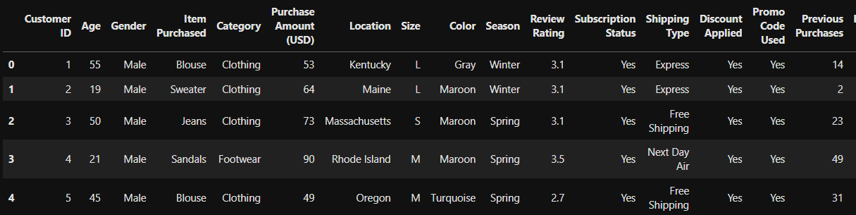
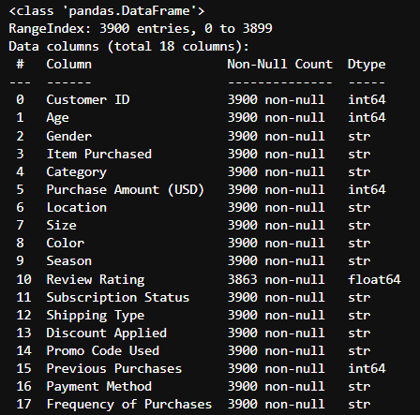
NULL VALUES:
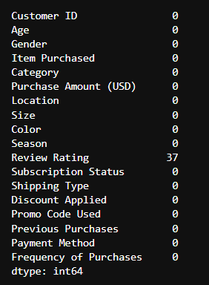

1.3 Data Understanding
- Identified numerical columns (such as age, purchase amount, quantity).
- Identified categorical columns (such as gender, product category, location, payment method).
- Reviewed column meanings to align data with business context.
1.4 Data Cleaning
- Checked for missing (null) values column-wise.
- Handled missing values using appropriate techniques such as removal or replacement where applicable.
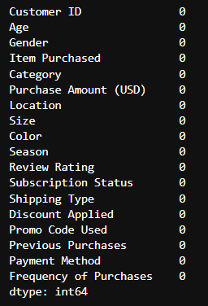
- Ensured data types were correct (e.g., numeric columns as integers/floats, categorical columns as strings).
- Renamed columns to maintain consistency and readability.
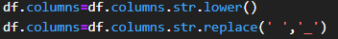
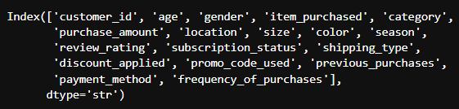
1.5 Feature Engineering
- Created additional columns to support better analysis (for example, age groups or spending ranges).
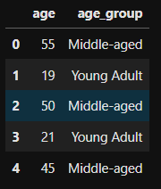
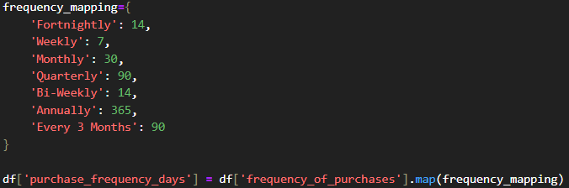
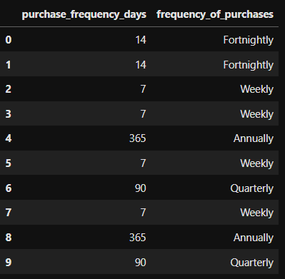
- Converted categorical codes into meaningful labels for better interpretation.
- Prepared the dataset so it could be easily queried using SQL.
1.6 Output Preparation
- Final cleaned dataset was validated for accuracy.
- Exported the processed dataset to be used in SQL and Power BI.

2. SQL Phase – Data Analysis Using Queries
2.1 Objective of SQL Phase
The SQL phase focuses on performing structured, business-oriented analysis on the cleaned dataset. SQL queries were written to answer key business questions related to sales performance, customer behavior, and product trends.
2.2 Database and Table Creation
- Imported the cleaned dataset into a relational database system.
- Created a customer shopping behavior table with appropriate data types.
- Ensured primary structure consistency with the Python-processed dataset.
2.3 Data Validation
- Verified record counts between Python output and SQL table.
- Checked for null values and data inconsistencies.
- Ensured data integrity before analysis.
2.4 SQL Queries for Business Insights
The following categories of queries were implemented:
- Calculation of total sales generated by Male and Female customers.
- Analysing which customer uses discount but still spends more than average purchase amount.
- Determining top 5 products with their high average review rating
- Comparing average purchase amount between Standard and Express Shipping.
- Finding out whether subscribed customers spend more?
- Identifying which 5 products have the highest percentage of purchases with applied discount.
- Differentiating customers into New, Returning and Loyal based on their history of purchase.
- Identifying which top 3 purchased products within each category.
- Determining whether repeat buyers also likely to subscribe.
- Calculating revenue contribution of each age group.
2.5 Use of SQL Concepts
- Applied aggregate functions such as SUM, AVG, COUNT, MIN, and MAX.
- Used GROUP BY to summarize data at customer, category, and demographic levels.
- Used ORDER BY to rank customers and products.
- Applied filtering conditions using WHERE and HAVING clauses.

3. Power BI Phase – Dashboard & Visualization
3.1 Objective of Power BI Phase
The Power BI phase focuses on converting analytical results into an interactive and visually appealing dashboard that enables stakeholders to quickly understand customer shopping behavior and key business metrics.
3.2 Data Import
- Imported the cleaned dataset or SQL query results into Power BI.
- Verified column names, data types, and data quality.
3.3 Data Modeling
- Established relationships where required.
- Created calculated columns and measures using DAX.
- Developed measures for total sales, average spending, number of customers, and purchase count.
3.4 Dashboard Design
- Designed a structured and professional dashboard layout.
- Used consistent color themes and fonts for better readability.
- Added key visuals including:
  - KPI cards for total sales, total customers, and average spending
  - Bar and column charts for category-wise and product-wise sales
  - Pie or donut charts for customer demographic distribution
  - Tables for detailed customer-level insights
3.5 Interactivity and Filters
- Added slicers for seasons and subscription status.
- Enabled cross-filtering so selections in one visual affect others.
3.6 Insights and Business Value
- Identified top-performing product categories and customer segments.
- Highlighted high-value and repeat customers.
- Provided actionable insights to support marketing and sales strategies.

Final Conclusion:
This project demonstrates a complete end-to-end data analytics pipeline. Python was used for data cleaning, feature engineering, and exploratory analysis. SQL was used for structured querying and extracting business insights. Power BI was used to create an interactive dashboard for data-driven decision-making. Together, these tools provide a comprehensive understanding of customer shopping behavior and support effective business strategies.

